Dashboard
Dashboard-the HOME page. From here the rest of the system can be navigated. The Dashboard allows users to drill down through reporting panels for applications, program budgets and view/update staff access information.
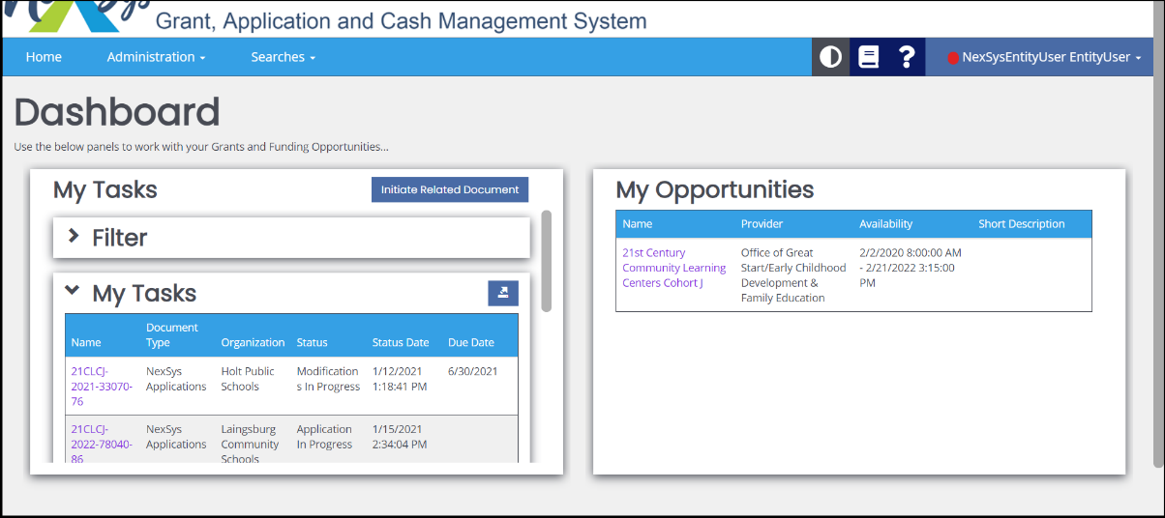
Home- Takes user back to the HOME dashboard
Administration- Edit/Add Users
Searches-Applications
Theme Setting- Switch from black and white color display
Training Materials
Help
Profile Menu- Messages, Edit Dashboard and Logout
My Tasks- Application “To Do” List assigned to the user
Filter- Limits the tasks that appear
My Opportunities- List of available applications for which the entity can apply

Dashboard-Profile Menu
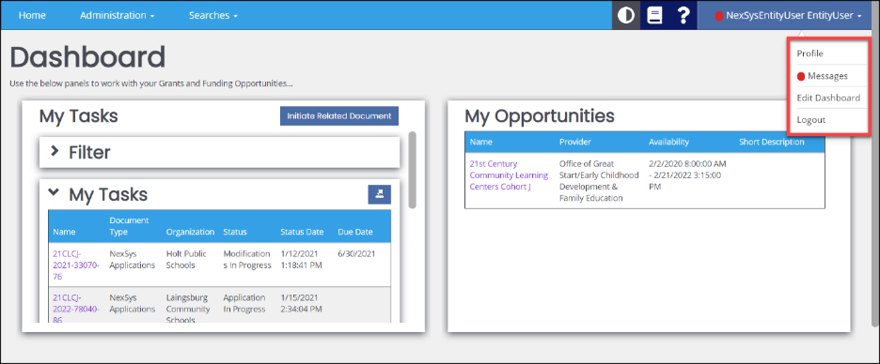
Profile- provides basic contact information, such as: name, address, phone, email, security image and username/password. Lists the organization(s) the user is affiliated to.
Messages- Send/receive messages
Edit Dashboard- Update the cards that display within a user’s dashboard.
Logout- End session

Dashboard-Administration
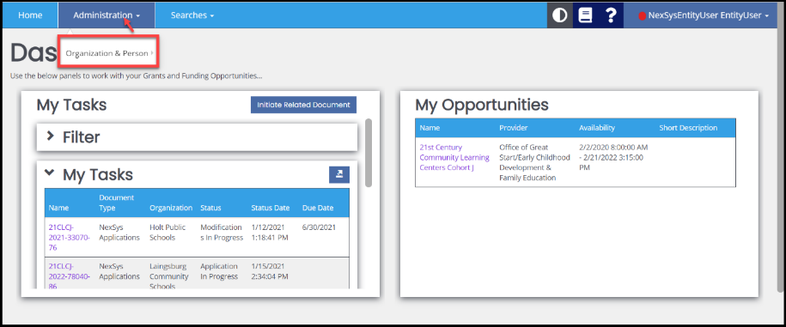
Organization & Person- add/find other system users. Verification of user role (level) and active/inactive date(s).

>Person Search- Enter in the appropriate criteria and click the “Search” button.
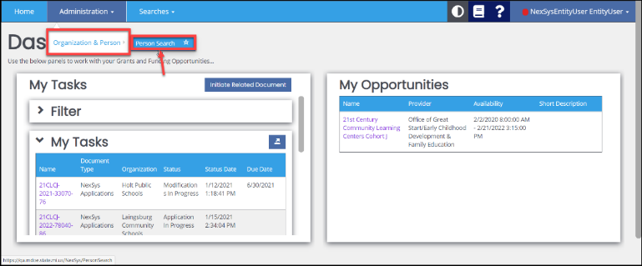

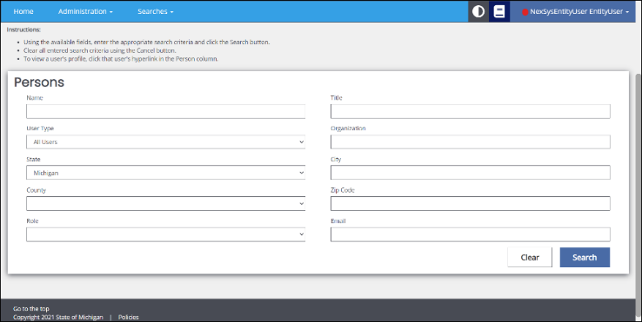

Dashboard-Searches
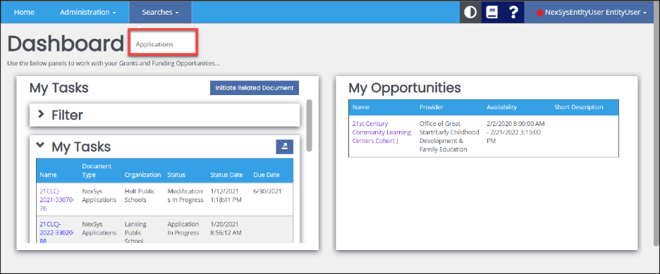
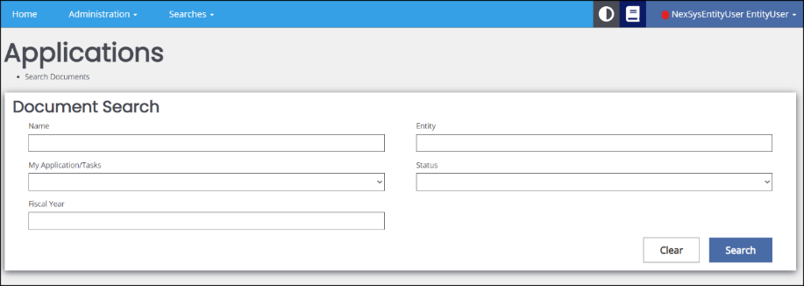
Applications- Navigate to “Searches” and click on Applications to search for other applications within the system using: Name, Type, Sub Code, Organization or Status.

My Opportunities
My Opportunities- Initiate an application(s) for which the entity assigned user is eligible to apply. The opportunities available depend on the user’s security level.
To initiate an Application:
1) Click on the application opportunity name listed under the Name column.
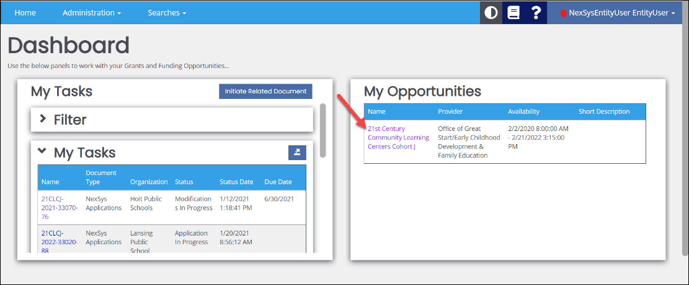
2) Once clicked, a window with basic information about the application opportunity will display. The user clicks “Agree” to initiate the application.
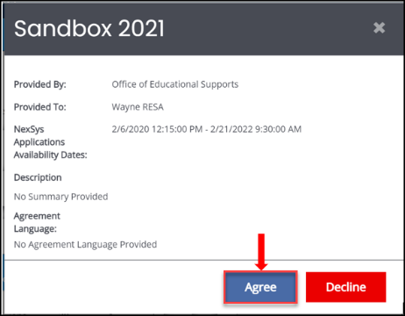
3) Once the user clicks on “Agree” the Document Overview page will display. This contains the “slide menu,” the main application navigation, on the left-hand side of the screen, the application progress bar and the “New Note” button.
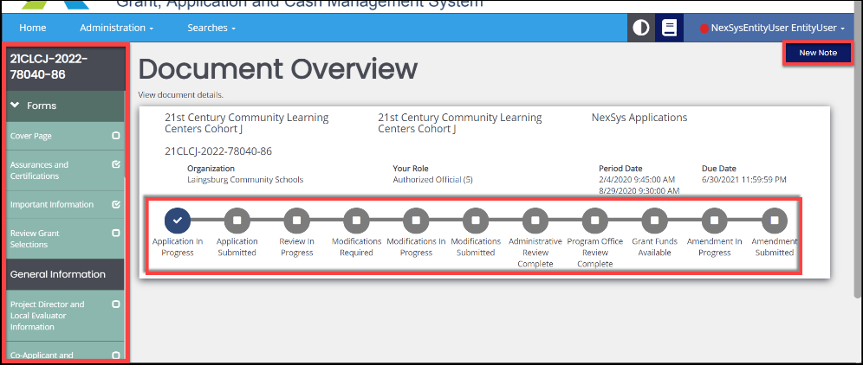
Application Progress Bar- Provides a visual path of the application approval process.
New Note- Notes can be added to applications by either the state agency or entity contacts can be found in the Notes section of the application. A note may also be added through the Notes page of the slide menu.
- An (!) will appear next to the word Notes (within the slide menu) if a new Note has been added for the entity to review.
Slide Menu- Scroll bar on the left-hand side of the page. Contains the required pages of the application. The available pages are dependent on the application type.
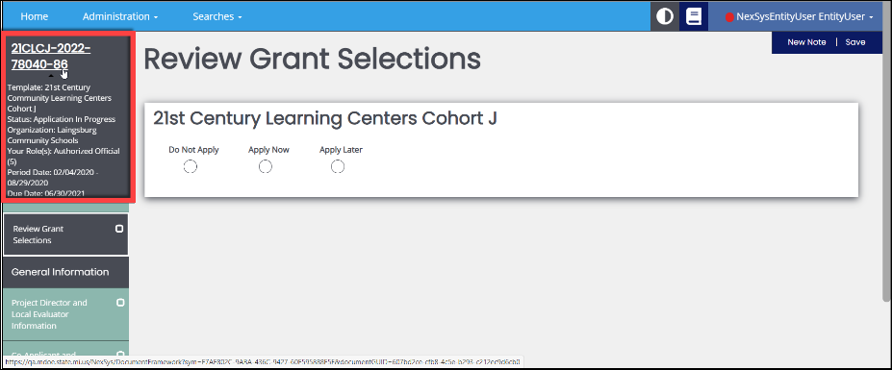

Hovering over the application document name will display the Document Overview Information.

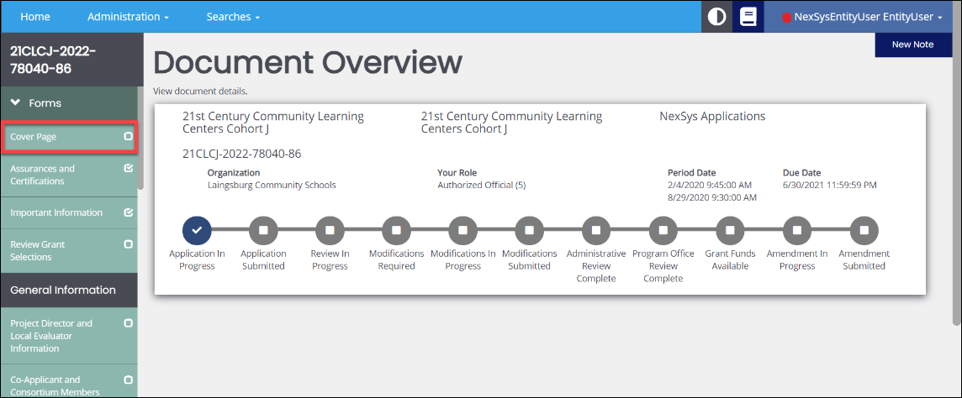

Most applications will include the following page requirements within the slide menu.
- Cover Page- Review contact information and select and enter Main and/or Secondary Contacts.

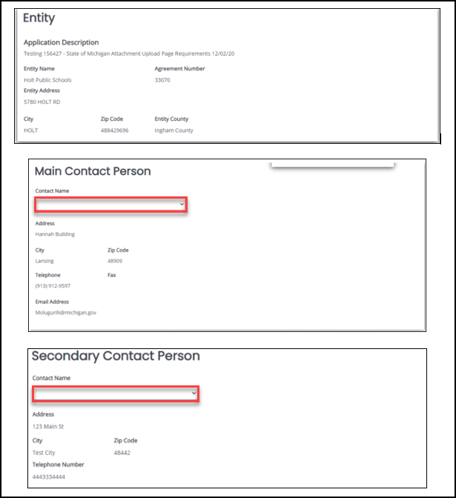

- Assurances and Certifications- Review the assurances (guarantees) and certifications (evidence) associated with the application.

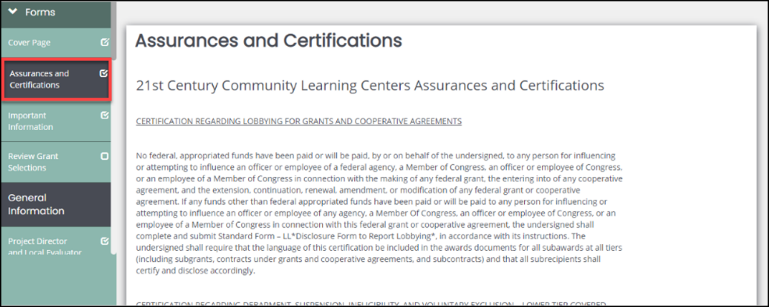

- Important Information- the user reviews important information associated with the application, such as updates.

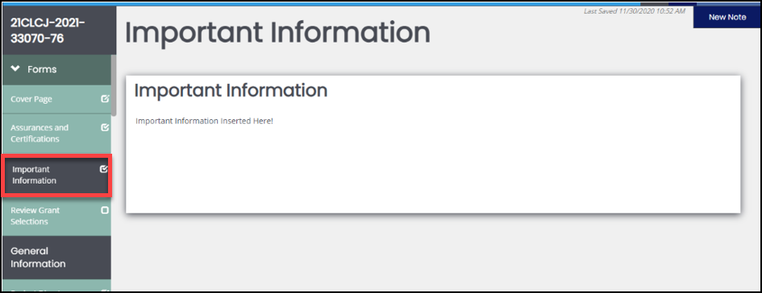

- Review Grant Selections- This page may appear if multiple funding sources are available within the application (consolidated grant application).

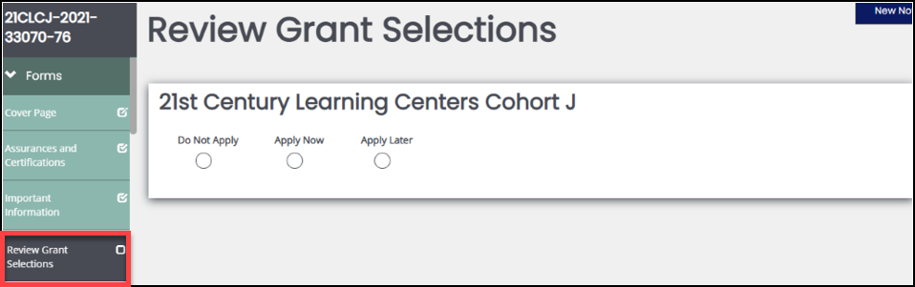

- General Information Heading- Varying pages will display based on the application requirements.

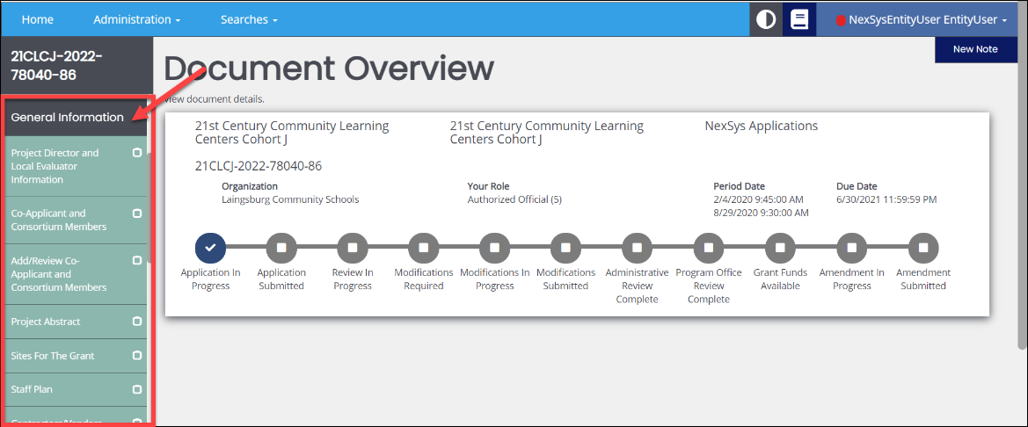

- Tools Section- User can select “Landing Page” which brings application back to the document overview.

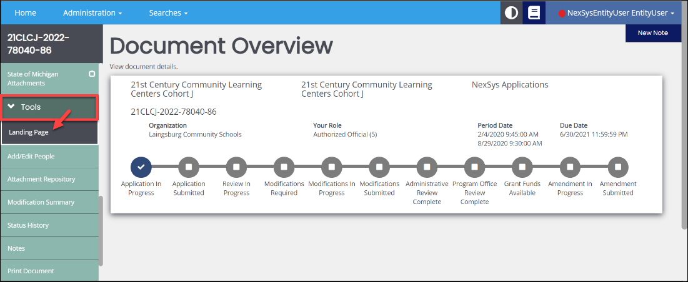

- Add/Edit People- Manage those assigned to the application and make additions or changes. Refer to the Adding Users Guide for step instructions on this process.

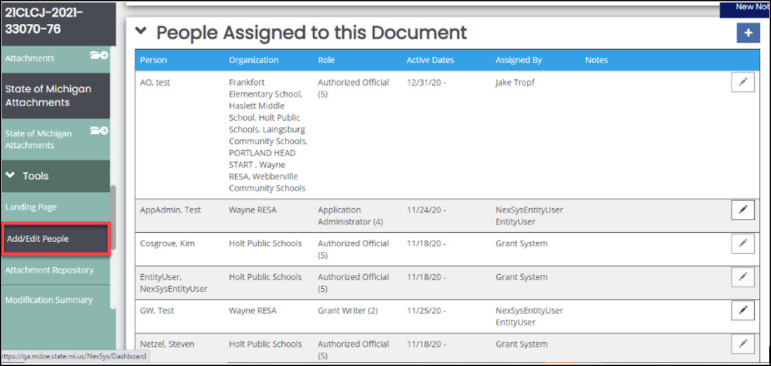

- Attachment Repository- Review the attachments in the application.

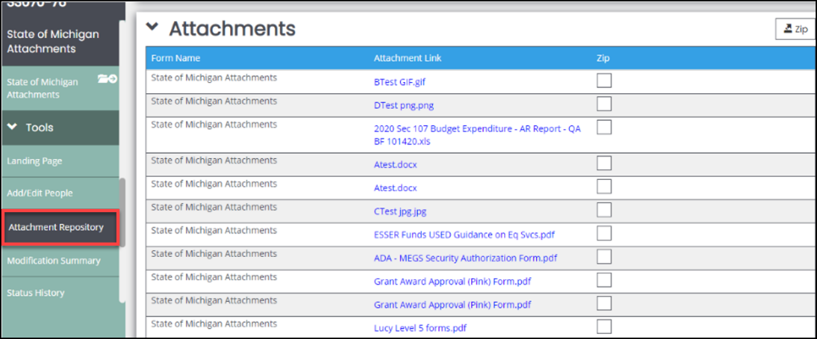

- Modification Summary- Review prior versions of the application.

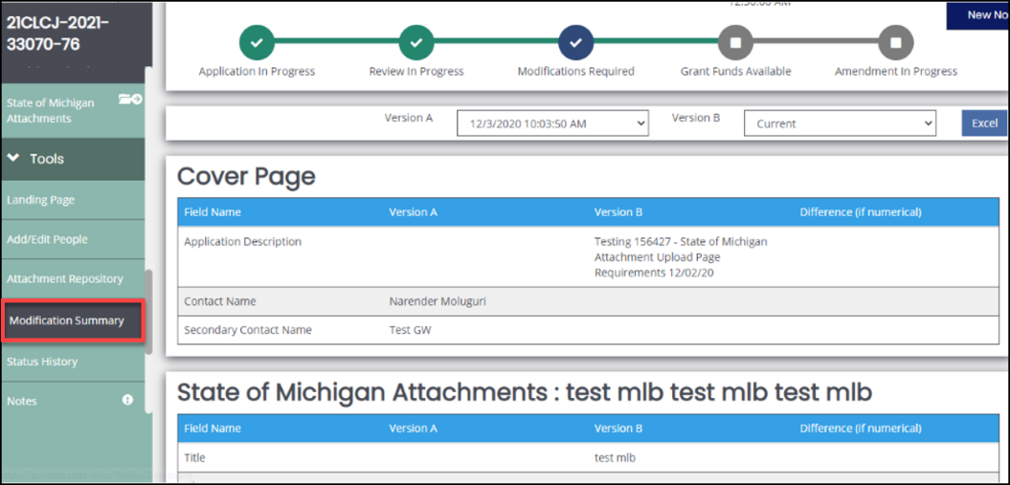

- Status History- Summary of the stages the application has been in and who
made the change(s).

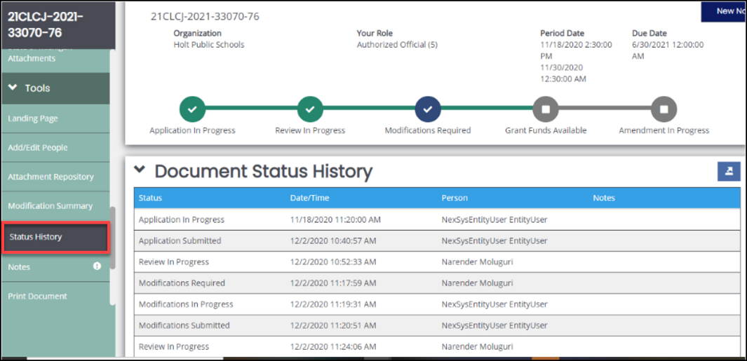

- Notes- See any comments added to the application by the reviewer. Entity
users may also add comments. When a new note is added an exclamation
point (!) will appear within the slide menu next to Notes.

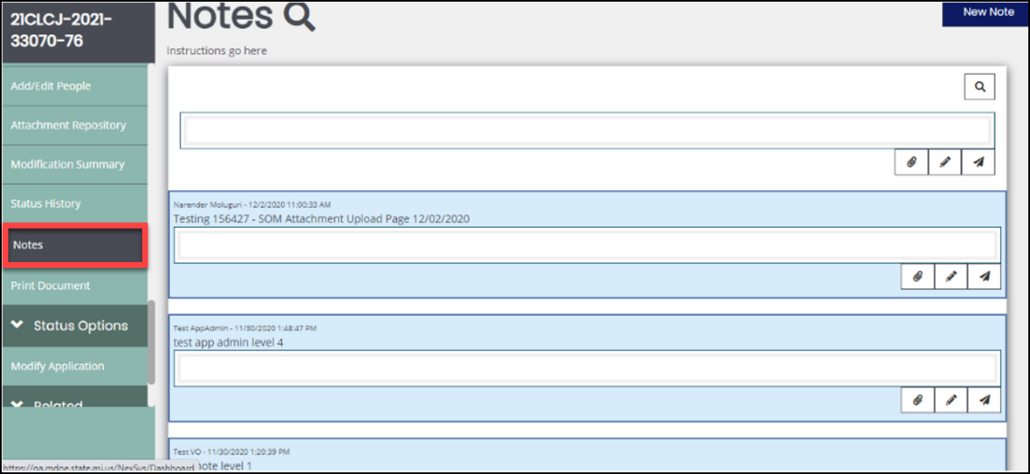

- Print Document- Choose and print components of the application.

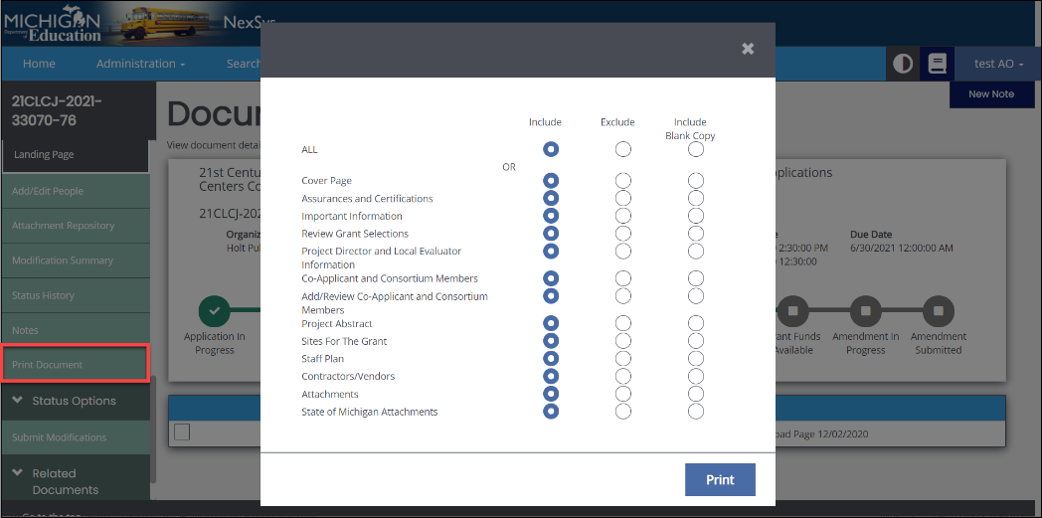

- Status Options- Changes the status of the application. Available statuses
are security level dependent.

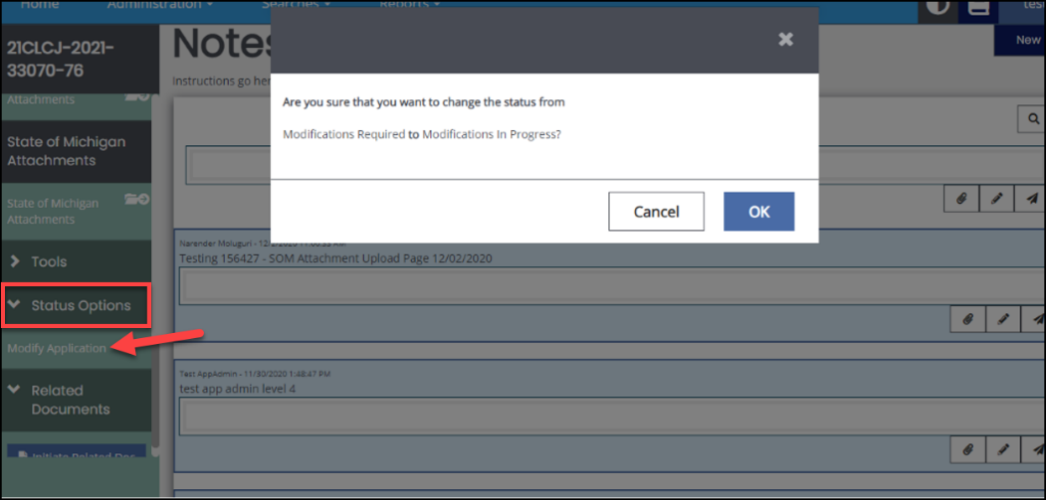

- Related Documents- View and initiate other related applications.

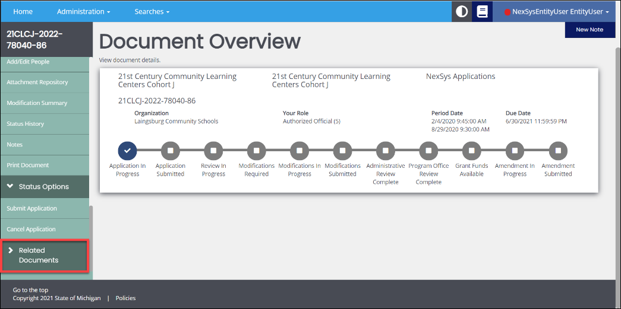

My Tasks
Shows all initiated documents that the user is assigned. Functions as a “to do” for the individual based on entity and access level.

- Filter allows the user to limit the tasks that appear.

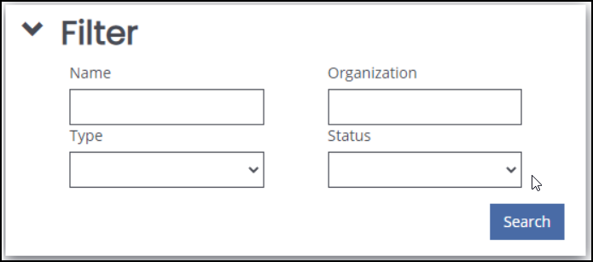

- User selects the task within the application they want to work on.

